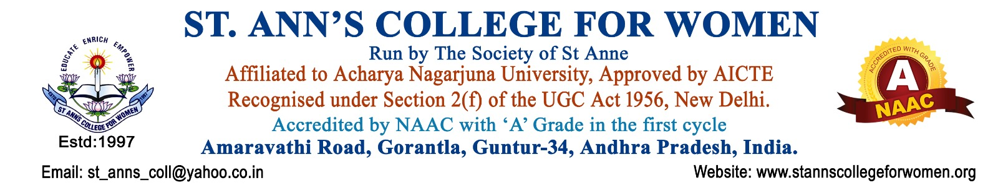

B.Com Honours (General)
The Department of Commerce at St. Ann’s College for Women offers the B.Com Honours (General) programme under the Four-Year Undergraduate Programme (FYUGP), designed to equip students with strong academic knowledge, practical skills, and professional competence in the fields of commerce, accounting, finance, taxation, and business management.
The programme provides a strong foundation in core areas such as Financial Accounting, Cost Accounting, Taxation, Economics, Business Law, Auditing, Financial Management, and Organizational Behaviour. It aims to prepare students for careers in finance, banking, accounting, taxation, entrepreneurship, and corporate sectors while also enabling them to pursue higher studies and professional courses.
Note: St. Ann’s College for Women presently offers the B.Com Honours (General) programme as a Three-Year Degree Programme in accordance with the Acharya Nagarjuna university and government guidelines.
About the Programme
B.Com Honours (General) is one of the most sought-after undergraduate programmes in the field of commerce. The curriculum is carefully designed to develop analytical, managerial, and entrepreneurial skills among students.
The programme:
- Provides in-depth knowledge of commerce, finance, taxation, and management.
- Develops accounting, decision-making, and problem-solving skills.
- Enhances professional competence required in business and corporate sectors.
- Encourages students to pursue research, innovation, and entrepreneurship.
- Prepares students for higher education such as M.Com, MBA, PGDM, and other professional programmes.
Students also gain exposure to practical learning through seminars, projects, internships, industrial visits, workshops, and research-based assignments.
Programme Objectives
The programme aims to:
- Build strong foundations in commerce and business studies.
- Develop financial and managerial decision-making abilities.
- Promote ethical and professional practices in business.
- Enhance employability and entrepreneurial skills.
- Prepare students for professional courses and competitive examinations.
Eligibility
Students seeking admission into B.Com Honours (General) must fulfil the following eligibility criteria:
- Pass in Intermediate / 10+2 or equivalent examination from a recognized board.
- Candidates from Commerce and other eligible streams may apply as per university norms.
Admission Process
Admissions into B.Com Honours (General) are made according to the guidelines issued by the Government of Andhra Pradesh and the affiliated university.
- Admissions are primarily based on merit.
- Convener quota admissions are filled through the centralized admission process notified by the Government of Andhra Pradesh.
- Limited seats are available under Management Quota.
For Management Quota admissions and further details, students may contact the college office.
Proposed Minor Course
Students may choose a minor course in:
- Business Management
Career Opportunities
Graduates of B.Com Honours (General) have wide career opportunities in commerce, banking, finance, taxation, insurance, auditing, and corporate sectors.
Some of the popular career options include:
- Accountant
- Business Consultant
- Finance Officer
- Tax Consultant
- Financial Consultant
- Bank Manager
- Stock Broker
- Auditor
- Investment Advisor
- Accounts Executive
Higher Education & Professional Courses
After completing the programme, students can pursue:
- M.Com
- MBA
- PGDM / PGPM
- Chartered Accountancy (CA)
- Cost & Management Accountancy (CMA)
- Company Secretary (CS)
- Chartered Financial Analyst (CFA)
- Certified Financial Planner (CFP)
Career Scope
The programme opens doors to employment opportunities in:
- Banks and Financial Institutions
- Corporate Companies
- Accounting Firms
- Insurance Companies
- Tax Consultancy Services
- Multinational Companies (MNCs)
- Government and Private Organizations
Students may also become entrepreneurs or pursue globally recognized professional certifications for advanced career growth in India and abroad.
Why Choose B.Com Honours (General) at St. Ann’s College for Women?
- Experienced and dedicated faculty
- Industry-oriented curriculum
- Skill enhancement and value-added courses
- Internship and project opportunities
- Career guidance and placement support
- Focus on academic excellence and holistic development
- Safe and empowering learning environment for women
- Placements
The programme at St. Ann’s College for Women is committed to empowering young women with knowledge, skills, values, and leadership qualities required for successful professional careers and lifelong learning.

